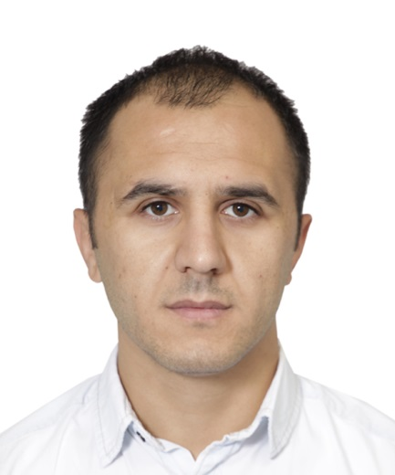

Dr Ferit Can YAZDIC received his BSc in Biology Department from Kahramanmaras Sutcu Imam University, has MSc and PhD in Zootechnics, Faculty of Agriculture from the same university in 2017. Dr YAZDIC is currently a assistant professor in the department of Biotechnology & Veterinary at the University of Munzur. During his master, he worked on the isolation, identification and enzymatic properties of anaerobic fungi. The subject of his doctoral thesis is about the molecular analysis of immune genes in cattle. He is currently working on anaerobic microbiology, biotechnology, animal genetics and genetic quality control.

E-mail: [fcanyazdic@munzur.edu.tr](mailto:fcanyazdic@munzur.edu.tr)