**Dr. Öğr. Üyesi Osman GÜLER**

**Adres:** Munzur Üniversitesi, Pertek Sakine Genç MYO, Veterinerlik Bölümü, Pertek / Tunceli,

**e-mail:** omguler@hotmail.com

**Doğum Yeri-Yılı:** Elazığ - 05/02/1966

**Uzmanlık Alanı:** Veteriner Farmakoloji ve Toksikoloji

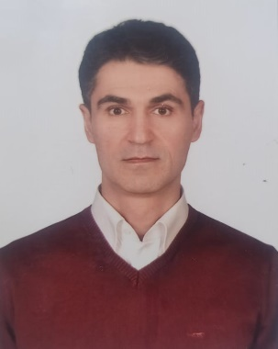

**Uluslararası Dergilerde Editörlük**

International Journal of Nature and Life Sciences Şef Editör 2017-…

(http://dergipark.gov.tr/ijnls)

International Research Journal of Plant Science Şef Editör 2010-2019

<http://www.interesjournals.org/irjps/editorial-board>

Journal of Anatolian Education Research Editör 2017-2018

(<https://www.janaeduc.com/index.php/ojs>)

Agrotechnology **Executive** Editör 2013

<https://www.longdom.org/editor/dr-ugur-cakilcioglu-10190>

International Journal of Botany Technical Editors 2013

<https://ansinet.com/eboard.php?issn=1811-9700>

Pakistan Journal of Biological Sciences Technical Editors 2012-…

<https://ansinet.com/eboard.php?issn=1028-8880>

[Asian Journal of Plant Sciences](http://scialert.net/jindex.php?issn=1682-3974) Technical Editors 2011-…

https://ansinet.com/eboard.php?issn=1682-3974

Turkish Journal of Botany **SCI Exp.** Alan Editörü 2016-2017

Ekological Life Science Alan Editörü 2009-….

(http://dergipark.gov.tr/nwsaecolife/board)

Education Sciences Editör Yrd. 2010-…

https://dergipark.org.tr/tr/pub/nwsaedu/board

**Uluslararası Dergilerde Yayın Kurulu Üyeliği**

Journal of Herbal Medicine **SCI Exp.** 2015-…

<http://www.journals.elsevier.com/journal-of-herbal-medicine/editorial-board/>

# South African Journal of Botany SCI Exp. 2015-…

http://www.journals.elsevier.com/south-african-journal-of-botany/editorial-board

Journal of Ethnobiology and Ethnomedicine **SCI Exp.** 2020-.

<https://ethnobiomed.biomedcentral.com/about/editorial-board>